Cairo University Faculty of Computers and Information



**Software Engineering II**

**Software design specification document**

**2020**

**Project Team**

|  |  |  |  |
| --- | --- | --- | --- |
| **ID** | **Name** | **Email** | **Mobile** |
| 20170010 | Ahmed Osama Mohamed | gqozgak1@gmail.com | 01021520304 |
| 20170047 | Eslam Adel Ismail | eslamadel11993377@gmail.com | 01114213042 |
| 20170011 | Ahmed Elsayed Ali | ahmed.elsayed24233@gmail.com | 01158110166 |
| 20170019 | Ahmed Ramadan | Ahmedramadan60000@gmail.com | 01114497386 |

**Mahmoud Haddad**

Title page has no header or footer.

Docs must be supplied as pdf –files re-named as requested

Contents

Class diagram design 2

Sequence diagram design 3

Github repository link 5

# Class diagram design

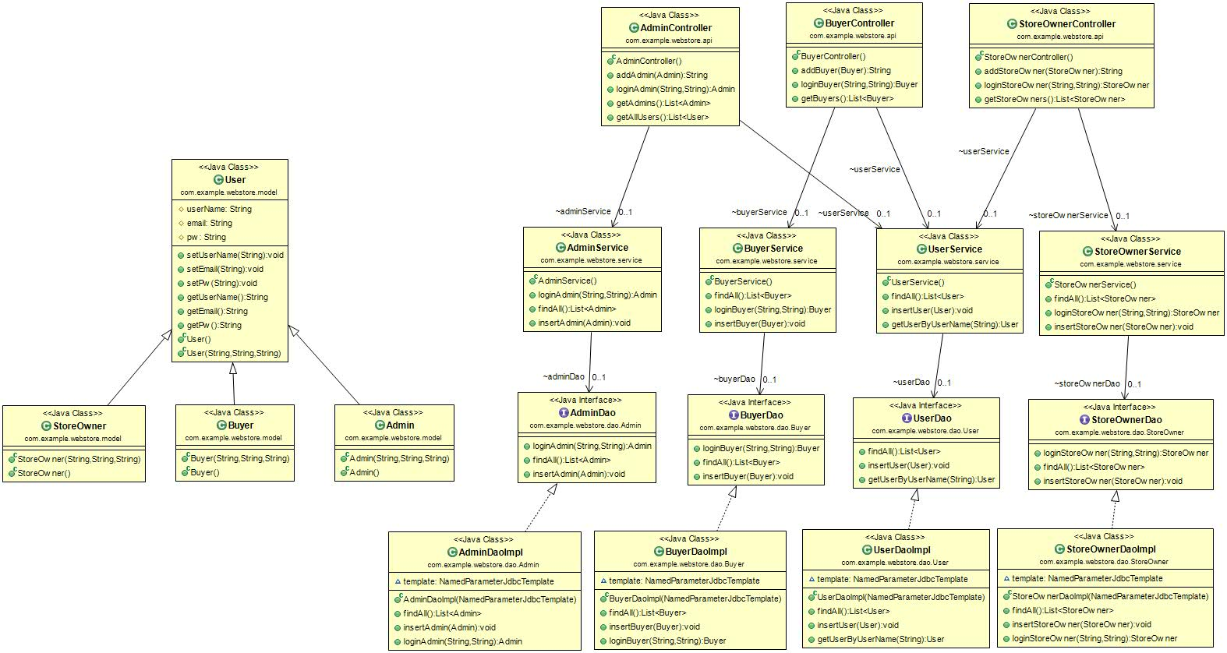

# Sequence diagram design

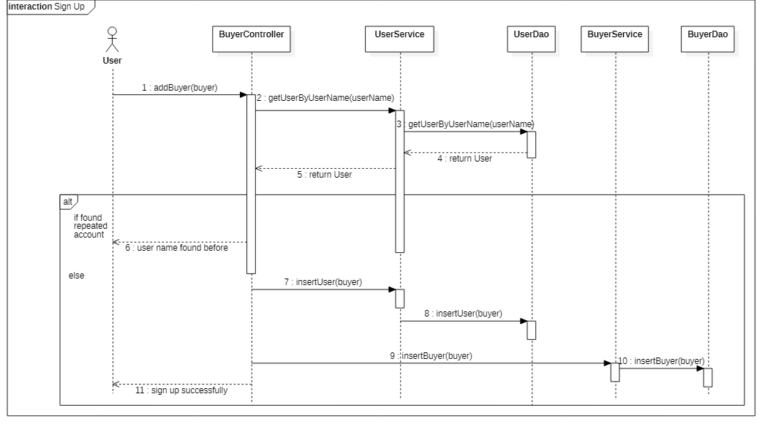

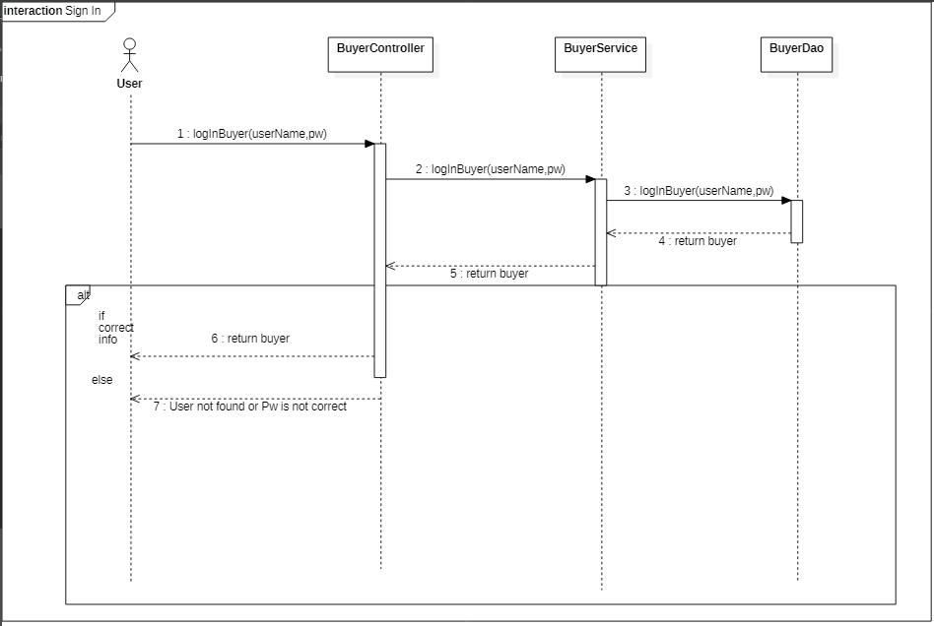

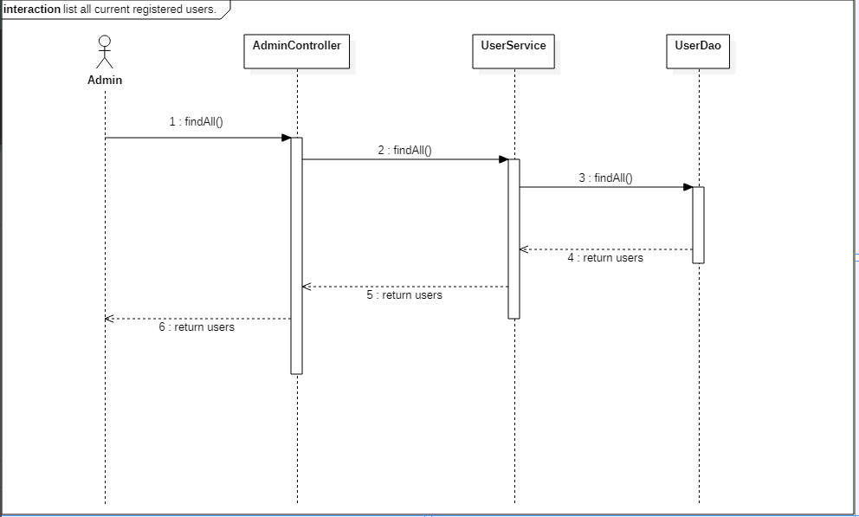

# Github repository link

<https://github.com/gqozgalz/SW_Project_WebStore>

note: private repository.